
CLASSIC ROUGE 2022

Country|Region|Appellation France|Bordeaux|Blaye Côtes de Bordeaux AOP

Property A vineyard managed by the Bantegnies family, owners of Château Bertinerie

Vineyard A surface of 60 hectares (148 acres) trained in the V-shaped Lyre, rare in Bordeaux. This is the largest vineyard employing this technique in France, which allows for better aeration and sun exposure of the grape bunches. In the humid Bordeaux climate, the Lyre enhances ripening with softer tannins and reduces fungal diseases. The wines have greater richness and substance consistently across vintages. The crop is thinned in August to improve concentration in the wines. Also uncommon in Bordeaux, the harvest is conducted by hand rather than machine. Average yield of 50 hectoliters per hectare (approximately 3.5 tons/acre)

Grape Varieties From 15 to 30 years old, vineyards are 65% Merlot, 30% Cabernet Sauvignon and 5% Cabernet Franc, a classic Right Bank Bordeaux blend. Merlot yields a soft, fruity red wine complemented by the firmness of Cabernet. The blend varies according to the conditions of the year
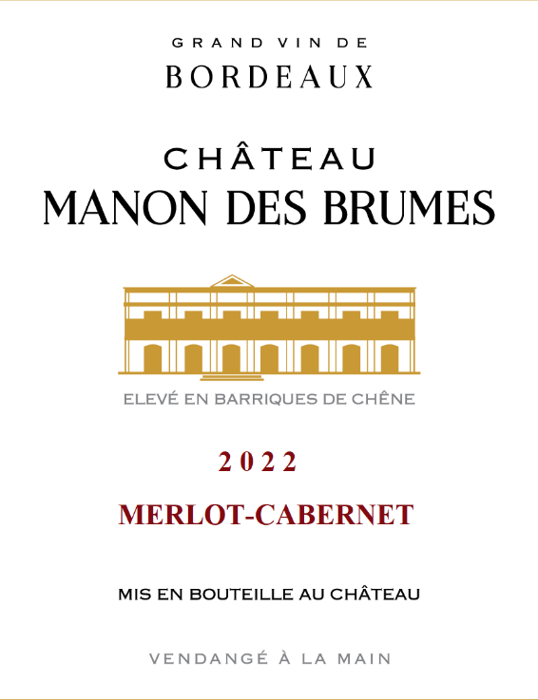
Winemaking The grapes are fully destemmed, then fermented and macerated for 15 to 20 days under temperature control (24 to 27°c). The malolactic conversion is in tank. Very few percentages of Press wine will be reintegrated inside the free-run wine to keep that creamy and fruity profile. 70% of the blend is aged for 12 months in two-year old barrels and 4 months in tank to avoid a strong flavor of oak. Fined and lightly filtered

Consumption Perfect during the first 5 years and still can bring pleasure until 10 years. An accessible Bordeaux red to drink young for its nice balance of fruit, freshness and complexity without any green tannins, thanks to the Lyre vineyards which brings a higher maturity

